# ***Challenge Name :- S3khmet's Shr0ud***

**Description:** Welcome to the S3khmet's Shr0ud ! Your mission, should you choose to accept it, is to exploit a ServerSide Request Forgery vulnerability. However, the server only accepts cryptic inputs that follow a specific encoding scheme. Can you decipher the secrets hidden within.

**Level:** Hard

**Solution:**

Step-1: You will see an injection point .

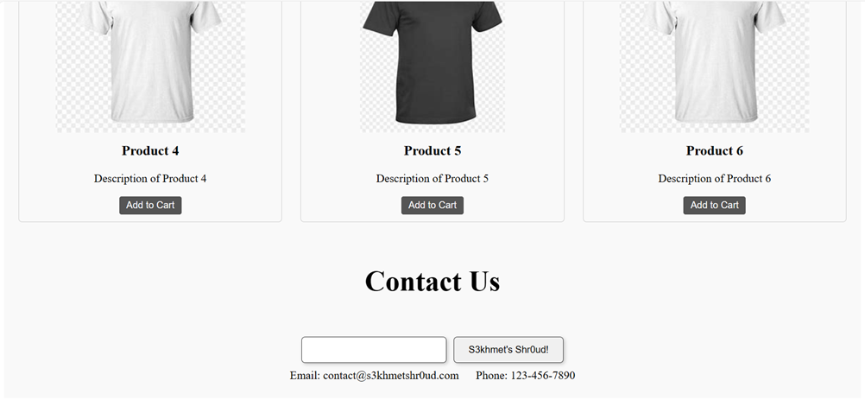

Step-2: When you put http://2130706433/ there the payload. It will give the message.

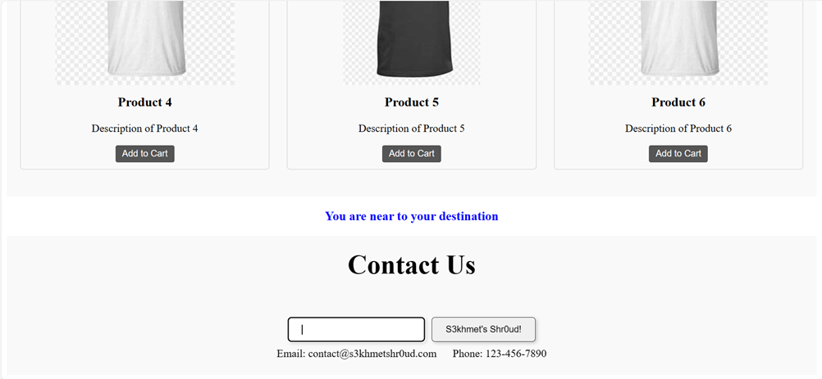

Step-3: When you see the code closely you will see a comment <!-- === --> 3 equal is symbol of base32 encode .

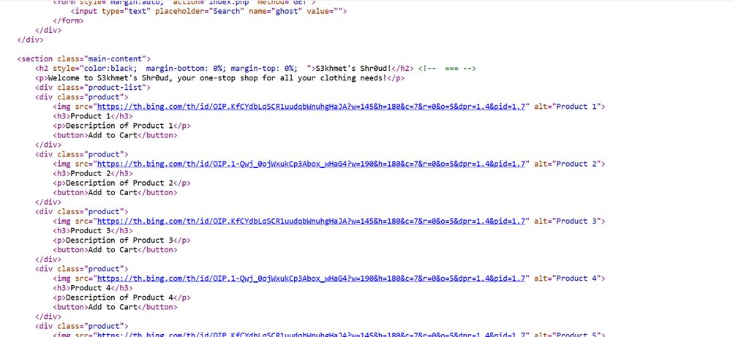

Payload: http://2130706433/ encode it base32

NB2HI4B2F4XTEMJTGA3TANRUGMZS6===

Note: During conversion if you select space also then it will give you wrong encoded data so care full.

https://emn178.github.io/online-tools/base32_encode.html

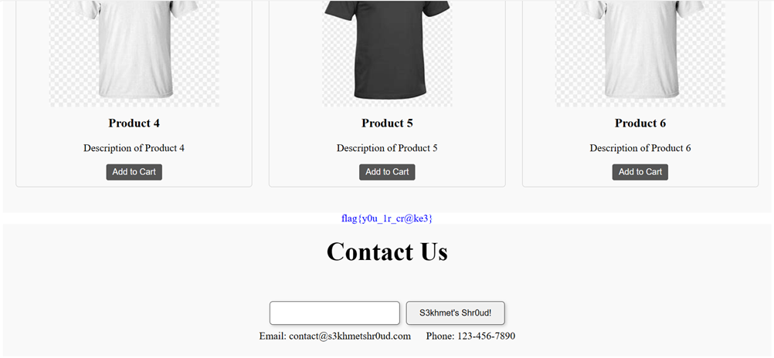

Flag: flag{y0u_1r_cr@ke3}

This page is intentionally left blank